Wilson Basketball Net
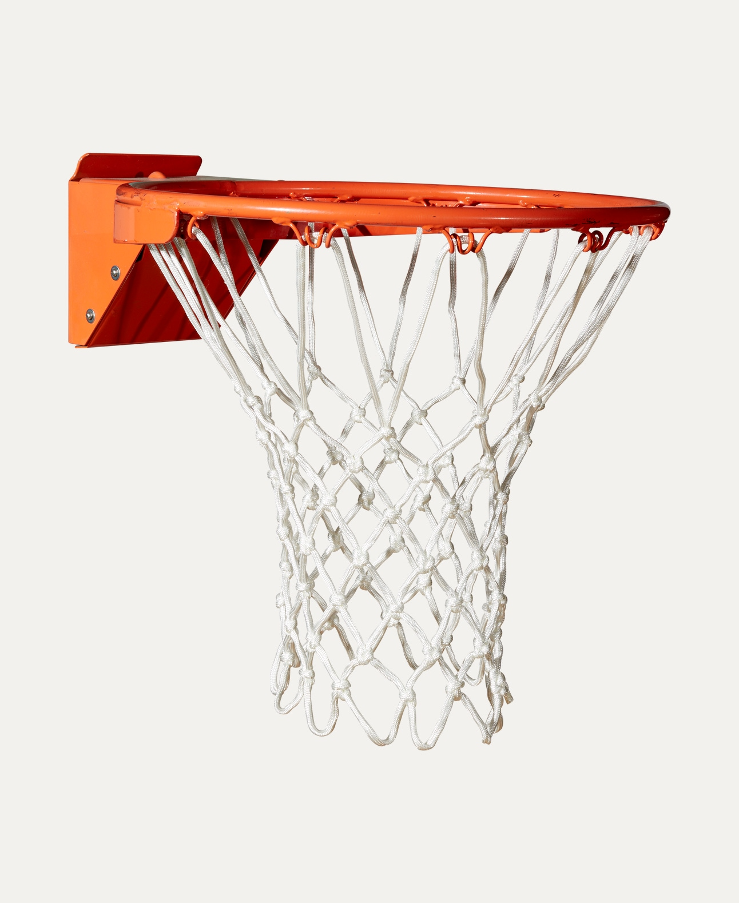
Price: Approximately Rs 7,000

Introduction
The Wilson Basketball Net is designed to deliver durability, smooth ball movement, and long-lasting performance. Ideal for both indoor and outdoor courts, it enhances the overall basketball playing experience.

Product Overview
This Wilson Basketball Net is crafted to fit standard basketball rims and provide consistent performance during games and practice sessions. Its strong construction ensures reliable use in all playing conditions.

About the Brand
Wilson is a world-renowned sports brand trusted by professional leagues, schools, and sports academies. Wilson basketball accessories are known for quality, strength, and performance-focused design.

Key Features
- Compatible with standard basketball rims
- Strong and secure attachment
- Smooth ball release
- Weather-resistant design
- Suitable for indoor and outdoor use

Design & Build Quality
The net features a classic loop design with reinforced knots to prevent tearing. Its well-balanced structure ensures smooth ball flow without tangling.

Storage & Capacity
Lightweight and compact, the net can be easily stored or carried without taking much space when not in use.

Material & Durability
Made from high-quality nylon or heavy-duty polyester (depending on model), the Wilson Basketball Net is built to withstand repeated shots, outdoor exposure, and regular gameplay.

Ideal For
- Schools and colleges
- Basketball courts and gyms
- Training academies
- Indoor and outdoor basketball setups

Care Instructions
- Clean with mild soap and water if needed
- Avoid sharp objects
- Store in a dry place when not in use
- Check attachments regularly

Product Specifications
- Brand: Wilson
- Product Type: Basketball Net
- Material: Nylon / Polyester
- Compatibility: Standard basketball rim
- Usage: Indoor & Outdoor

Product Summary
The Wilson Basketball Net offers durability, smooth performance, and easy installation. It is a reliable choice for players and facilities looking for a long-lasting, professional-quality basketball net.

Thank you

